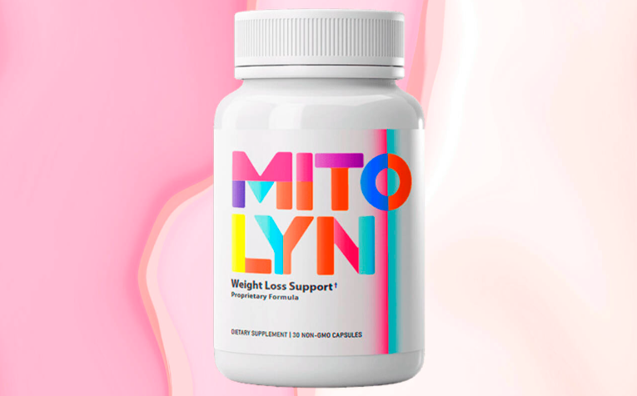

**✅ [Click Here to GET ORIGINAL Aqua Sculpt Now from Official Website - SAVE 87% TODAY + FREE US SHIPPING!](https://nz-mitolyn.com.au/)**

**-----------------------------------------------------------------------------------------------------------------**

**Mitolyn – Your Ultimate Energy and Wellness Booster**

In today's fast-paced world, maintaining high energy levels, a healthy metabolism, and mental clarity can be challenging. That’s where Mitolyn comes in—a powerful supplement designed to enhance energy, support metabolism, and promote overall well-being with natural and scientifically backed ingredients.

**What is Mitolyn?**

[**Mitolyn**](https://nz-mitolyn.com.au/) is a premium health supplement that helps your body function optimally by supporting cellular energy production, metabolic efficiency, and cognitive health. Unlike artificial stimulants that lead to crashes, Mitolyn works at the mitochondrial level, ensuring sustained energy and long-term benefits.

**How Does Mitolyn Work?**

* [**Boosts Cellular Energy**](https://nz-mitolyn.com.au/)**:** Enhances mitochondrial function to keep you active throughout the day.
* [**Supports Metabolism**](https://nz-mitolyn.com.au/)**:** Helps convert stored fat into energy, aiding in weight management.
* [**Improves Focus & Mental Clarity**](https://nz-mitolyn.com.au/)**:** Combats brain fog and supports cognitive function.
* [**Strengthens Immunity**](https://nz-mitolyn.com.au/)**:** Provides essential nutrients to keep your immune system strong.

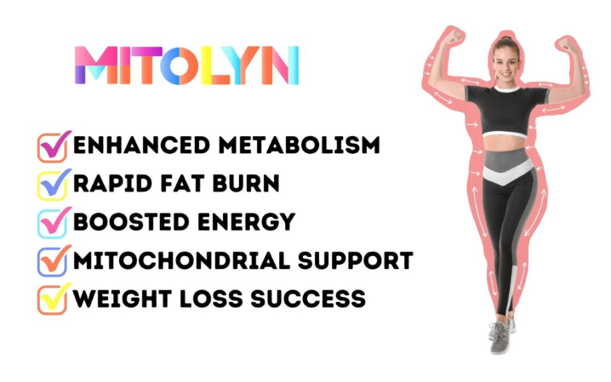

**🚨[LIMITED TIME OFFER – 86% OFF – TODAY ONLY](https://www.openpr.com/news/3840195/mitolyn-reviews-my-honest-experience-benefits-and-real)**

**--------------------------------------------------------------------------------------------------------------------------**

**Benefits of Mitolyn**

✔ [**Increases Energy & Stamina**](https://www.openpr.com/news/3840195/mitolyn-reviews-my-honest-experience-benefits-and-real) **–** Say goodbye to fatigue.

✔ [**Enhances Mental Focus & Clarity**](https://www.openpr.com/news/3840195/mitolyn-reviews-my-honest-experience-benefits-and-real) **–** Stay sharp and productive.

✔ [**Supports Healthy Metabolism**](https://www.openpr.com/news/3840195/mitolyn-reviews-my-honest-experience-benefits-and-real) **–** Helps manage weight effectively.

✔ [**Boosts Immune Function**](https://www.openpr.com/news/3840195/mitolyn-reviews-my-honest-experience-benefits-and-real) **–** Provides essential nutrients for overall health.

✔ [**Reduces Stress & Fatigue**](https://www.openpr.com/news/3840195/mitolyn-reviews-my-honest-experience-benefits-and-real) **–** Keeps you feeling refreshed and energized.

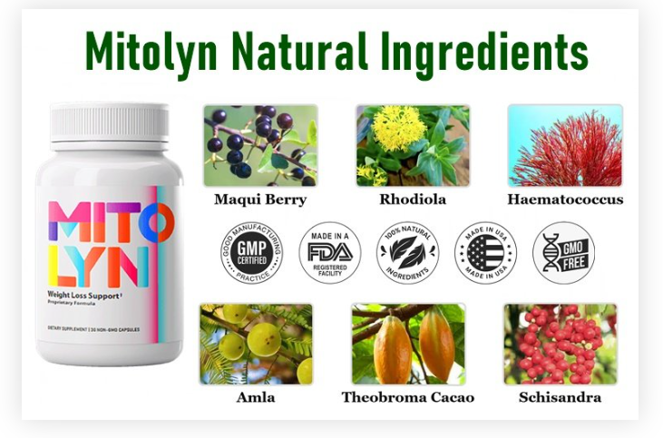

**[Click here to get it from the official website (Special Discount Code Applied)](https://nz-mitolyn.com.au/)**

**---------------------------------------------------------------------------------------------------------------------------------------------**

**Key Ingredients in Mitolyn**

**✔** [**Coenzyme Q10 (CoQ10)**](https://www.facebook.com/groups/mitolynnewzealandreview) **–** Enhances energy production and heart health.

**✔** [**L-Carnitine**](https://www.facebook.com/groups/mitolynnewzealandreview) **–** Converts fat into energy and boosts stamina.

**✔** [**Alpha Lipoic Acid (ALA)**](https://www.facebook.com/groups/mitolynnewzealandreview) **–** Supports metabolism and protects against oxidative stress.

✔ [**B Vitamins (B1, B6, B12)**](https://www.facebook.com/people/Mitolyn-Australia-New-Zealand-Reviews/61572507220712/) **–** Improve cognitive function and energy levels.

**✔** [**Magnesium**](https://www.facebook.com/people/Mitolyn-Australia-New-Zealand-Reviews/61572507220712/) **–** Essential for muscle function and stress relief.

**✔** [**Green Tea Extract**](https://www.facebook.com/share/p/167VoZmadr/) **–** Boosts metabolism and enhances focus.

**✔** [**Turmeric Extract**](https://www.facebook.com/share/p/167VoZmadr/) **–** Reduces inflammation and supports overall wellness.

**How to Use Mitolyn**

Take 1-2 capsules daily with water, preferably with a meal. For best results, combine with a healthy diet and regular exercise.

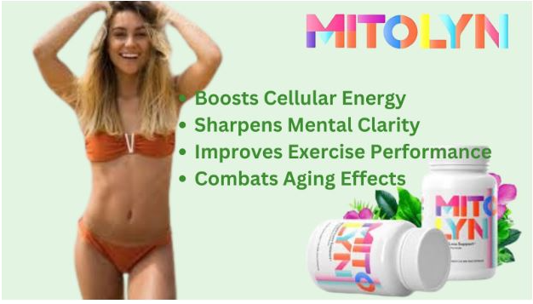

**👀❤️**[**CLICK HERE TO VISIT THE OFFICIAL WEBSITE & GET CUSTOMER SUPPORT**](https://nz-mitolyn.com.au/)**👀❤️**

**------------------------------------------------------------------------------------------------------------------------------------------------**

**Mitolyn: Pros, Cons:**

**Pros**

**✅ Boosts Energy Naturally –** Enhances mitochondrial function for sustained energy without crashes.

**✅ Supports Metabolism –** Helps in fat conversion and weight management.

**✅ Improves Cognitive Function –** Enhances focus, memory, and mental clarity.

**✅** [**Strengthens Immunity – Contains antioxidants and essential vitamins for overall health.**](https://getmitolyn.wordpress.com/)

**✅ Reduces Fatigue & Stress –** Supports muscle function and recovery.

**✅ Natural Ingredients –** Free from artificial stimulants and harmful additives.

**✅ No Jitters or Crashes –** Unlike caffeine-based supplements, Mitolyn provides balanced energy.

**Cons**

**❌ Results May Vary –** Effectiveness depends on individual health and lifestyle.

**❌** [**Not a Quick Fix – Requires consistent use for noticeable benefits.**](https://getmitolyn.wordpress.com/)

**❌** [**Mild Digestive Issues – Some users may experience bloating or stomach discomfort initially.**](https://sites.google.com/view/mitolynbuyy/home)

**❌ Allergic Reactions –** Rare, but possible if sensitive to specific ingredients.

**❌ Availability –** Mostly sold online, which may not be convenient for all buyers.

**✅**[**(MUST SEE) Click Here To VISIT Mitolyn Official Website - FIND OUT MORE!**](https://nz-mitolyn.com.au/)

**----------------------------------------------------------------------------------------------------------------------------------------------------**

**Potential Side Effects of Mitolyn**

**🔸 Mild Digestive Issues –** Some users may experience bloating, nausea, or stomach upset in the beginning.

**🔸** [**Headaches**](https://mitolynreviewsbuy.blogspot.com/2025/01/mitolyn-pros-cons-and-where-to-buy-it.html) **–** Can occur due to an adjustment period, especially with increased energy levels.

**🔸** [**Insomnia (Rare Cases)**](https://mitolynreviewsbuy.blogspot.com/2025/01/mitolyn-pros-cons-and-where-to-buy-it.html) **–** If taken too late in the day, the energy boost may interfere with sleep.

**🔸 Allergic Reactions –** Individuals allergic to ingredients like green tea or turmeric may experience skin irritation or mild swelling.

**Who Should Avoid Mitolyn?**

⚠ [**Pregnant or breastfeeding women (consult a doctor first).**](https://colab.research.google.com/drive/1Jki3JYBj0nm5Jad9CjqUyWB71pVZjNvm)

⚠ [**Individuals with pre-existing medical conditions or those on medication.**](https://www.wattpad.com/story/389053663-mitolyn-reviews-can-it-really-enhance-your)

⚠ [**Anyone allergic to its ingredients.**](https://www.wattpad.com/story/389053663-mitolyn-reviews-can-it-really-enhance-your)

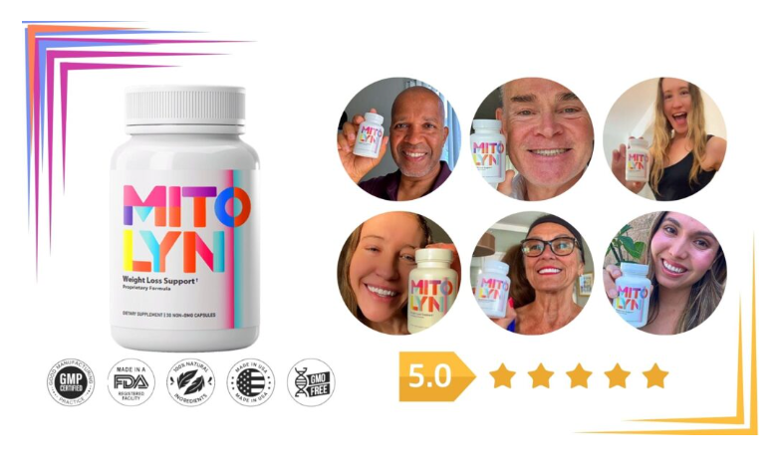

**☘📣**[**𝐒𝐚𝐥𝐞 𝐈𝐬 𝐋𝐢𝐯𝐞**](https://nz-mitolyn.com.au/) **🟢** [**𝐂𝐡𝐞𝐜𝐤 𝐍𝐨𝐰**](https://nz-mitolyn.com.au/)**😍😍👇**

**-----------------------------------------------------------------------------------------------------------------------------------**

**Where to Buy Mitolyn?**

**Mitolyn** is available exclusively online through official websites. Secure your supply today and take the first step toward better energy, metabolism, and overall well-being.

**Final Thoughts**

**Mitolyn** is a safe and effective supplement for energy, metabolism, and overall wellness when used correctly. It provides natural, sustained energy without crashes, but it’s always best to consult a doctor before starting any supplement.

**Official Website: -** **<https://nz-mitolyn.com.au/>**

**Also Check:-** [**https://www.openpr.com/news/3840195/mitolyn-reviews-my-honest-experience-benefits-and-real**](https://www.openpr.com/news/3840195/mitolyn-reviews-my-honest-experience-benefits-and-real)

**Facebook: -** [**https://www.facebook.com/share/p/167VoZmadr/**](https://www.facebook.com/share/p/167VoZmadr/)

[**https://www.facebook.com/people/Mitolyn-Australia-New-Zealand-Reviews/61572507220712/**](https://www.facebook.com/people/Mitolyn-Australia-New-Zealand-Reviews/61572507220712/)

[**https://www.facebook.com/groups/mitolynnewzealandreview**](https://www.facebook.com/groups/mitolynnewzealandreview)

[**https://www.facebook.com/trymitolynreviewsofficial/**](https://www.facebook.com/trymitolynreviewsofficial/)

**Pinterest: -** [**https://www.pinterest.com/buymitolyn/**](https://www.pinterest.com/buymitolyn/)

**Blogs: -** [**https://bitcointalk.org/index.php?topic=5528499**](https://bitcointalk.org/index.php?topic=5528499)

[**https://mitolyn3.godaddysites.com/**](https://mitolyn3.godaddysites.com/)

[**https://getmitolyn.wordpress.com/**](https://getmitolyn.wordpress.com/)

[**https://buymitolyn.company.site/**](https://buymitolyn.company.site/)

[**https://sites.google.com/view/mitolynbuyy/home**](https://sites.google.com/view/mitolynbuyy/home)

[**https://medium.com/@MitolynWeightLoss/mitolyn-does-it-really-work-an-honest-review-91ecd5bb6cd4**](https://medium.com/@MitolynWeightLoss/mitolyn-does-it-really-work-an-honest-review-91ecd5bb6cd4)

[**https://colab.research.google.com/drive/1Jki3JYBj0nm5Jad9CjqUyWB71pVZjNvm**](https://colab.research.google.com/drive/1Jki3JYBj0nm5Jad9CjqUyWB71pVZjNvm)

[**https://www.wattpad.com/story/389053663-mitolyn-reviews-can-it-really-enhance-your**](https://www.wattpad.com/story/389053663-mitolyn-reviews-can-it-really-enhance-your)

[**https://mitolynreviewsbuy.blogspot.com/2025/01/mitolyn-pros-cons-and-where-to-buy-it.html**](https://mitolynreviewsbuy.blogspot.com/2025/01/mitolyn-pros-cons-and-where-to-buy-it.html)

[**https://www.quora.com/profile/Mitolyn-Reviews-21/What-is-Mitolyn-Mitolyn-is-a-premium-weight-loss-supplement-meticulously-crafted-to-support-fat-loss-enhance-metaboli**](https://www.quora.com/profile/Mitolyn-Reviews-21/What-is-Mitolyn-Mitolyn-is-a-premium-weight-loss-supplement-meticulously-crafted-to-support-fat-loss-enhance-metaboli)

[**https://teeshopper.in/store/mitolynweightloss**](https://teeshopper.in/store/mitolynweightloss)

[**https://www.reddit.com/r/WegovyWeightLoss/comments/1idqyle/mitolyn_benefits_how_this_supplement_boosts/**](https://www.reddit.com/r/WegovyWeightLoss/comments/1idqyle/mitolyn_benefits_how_this_supplement_boosts/)

[**https://mix.com/mitolynweightloss**](https://mix.com/mitolynweightloss)

[**https://www.scoop.it/topic/mitolyn-reviews-by-mitolyn-74**](https://www.scoop.it/topic/mitolyn-reviews-by-mitolyn-74)

[**https://dzone.com/articles/mitolyn-how-it-works-benefits-ingredients-and-side**](https://dzone.com/articles/mitolyn-how-it-works-benefits-ingredients-and-side)

[**https://www.pearltrees.com/mitolynweightloss**](https://www.pearltrees.com/mitolynweightloss)

**<https://mitolynreview.livejournal.com/283.html>**

[**https://colab.research.google.com/drive/1aHXlMpLz0P3wCKKhHfuIYHGmNyNtDKdK#scrollTo=_zftcui1n9Mh**](https://colab.research.google.com/drive/1aHXlMpLz0P3wCKKhHfuIYHGmNyNtDKdK#scrollTo=_zftcui1n9Mh)

[**https://teeshopper.in/store/Mitolyn-Weight-Losss**](https://teeshopper.in/store/Mitolyn-Weight-Losss)

[**https://hackmd.io/@mitolynweightloss/Mitolyn**](https://hackmd.io/@mitolynweightloss/Mitolyn)

[**https://www.quora.com/profile/Mitolyn-18/What-is-Mitolyn-Mitolyn-https-nz-mitolyn-com-au-is-a-dietary-supplement-formulated-to-support-mitochondrial-hea**](https://www.quora.com/profile/Mitolyn-18/What-is-Mitolyn-Mitolyn-https-nz-mitolyn-com-au-is-a-dietary-supplement-formulated-to-support-mitochondrial-hea)

[**https://www.quora.com/profile/Mitolyn-18/What-is-Mitolyn-Mitolyn-https-nz-mitolyn-com-au-is-a-dietary-supplement-formulated-to-support-mitochondrial-hea**](https://www.quora.com/profile/Mitolyn-18/What-is-Mitolyn-Mitolyn-https-nz-mitolyn-com-au-is-a-dietary-supplement-formulated-to-support-mitochondrial-hea)

[**https://community.diybeer.com/topic/30440-mitolyn-reviews-heres-our-unbiased-review-after-we-tried-it/**](https://community.diybeer.com/topic/30440-mitolyn-reviews-heres-our-unbiased-review-after-we-tried-it/)

**#MitolynReviews**

**#Mitolyn**

**#MitolynSupplement**

**#MitolynWeightLossSupplement**

**#MitolynOfficialWebsite**

**#MitolynWheretobuy**

**#Mitolyncustomerreviews**

**#MitolynReview**

**#Mitolyncustomerreviews**

**#Mitolynweightlosssupplementreviews**

**#Mitolynreviews**

**#Mitolynsupplementreview**

**#Mitolynweightloss**

**#Mitolynsideeffects**

**#Mitolynbenefits**

**#Mitolyningredients**

**#Mitolynweightlossreviews**

**#Mitolynwebsite**

**#Mitolynofficial**

**#Mitolynofficialwebsite**

**#weightlosstransformation**

**#weightlossmotivation**

**#weightlossgoals**